Political Ideology Prediction Quiz
Using at least 3 factors for each person, identify which Ideology (Liberal or Conservative) the person most likely identifies with. Each person also has at least one factor that does not fit the stereotype, identify it.

1.  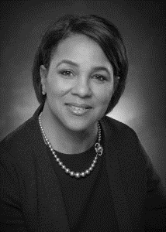 | Name: Jane  Gender: Female  Race: African-American  Age: 52  Location: Atlanta, Georgia  Education: M.D.  Occupation: Neurosurgeon  Religion: Methodist | Your Prediction and Rationale:
2. | Name: Paul  Gender: Male  Race: White  Age: 34  Location: Woodstock, Vermont  Education: Masters in Theology  Occupation: Pastor  Religion: Baptist | Your Prediction and Rationale:
3. | Name: Becky  Gender: Female  Race: White  Age: 40  Location: Salt Lake City, Utah  Education: Associates Degree  Occupation: Loan Officer  Religion: Mormon | Your Prediction and Rationale:
4.  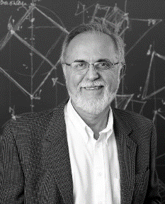 | Name: Dave  Gender: Male  Race: White  Age: 62  Location: Indianapolis, Indiana  Education: PhD  Occupation: Professor  Religion: Unitarian Universalist | Your Prediction and Rationale:
5. | Name: Mark  Gender: Male  Race: White  Age: 32  Location: Palo Alto, California  Education: Some College  Occupation: CEO  Religion: Judaism | Your Prediction and Rationale:
6. | Name: Priscilla  Gender: Female  Race: Asian-American  Age: 22  Location: Houston, Texas  Education: College Student  Occupation: Student  Religion: Catholic | Your Prediction and Rationale:
7.  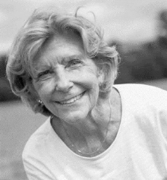 | Name: Rhoda  Gender: Female  Race: White  Age: 82  Location: Birmingham, Alabama  Education: High School  Occupation: Teacher  Religion: Atheist | Your Prediction and Rationale:
8.  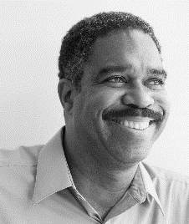 | Name: William  Gender: Male  Race: African-American  Age: 65  Location: Lynchburg, Virginia  Education: High School  Occupation: Retired Military  Religion: Atheist | Your Prediction and Rationale:
9.  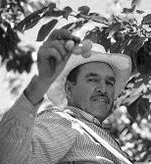 | Name: Ricardo  Gender: Male  Race: Hispanic  Age: 54  Location: Baton-Rouge, Louisiana  Education: Less than High School  Occupation: Farmer  Religion: Catholic | Your Prediction and Rationale:
10. | Name: Pamela  Gender: Female  Race: White  Age: 49  Location: Columbia, South Carolina  Education: High School  Occupation: Unemployed  Religion: Pentecostal | Your Prediction and Rationale:

